**SHACMAN X3000 8X4 DUMP Truck自卸车**

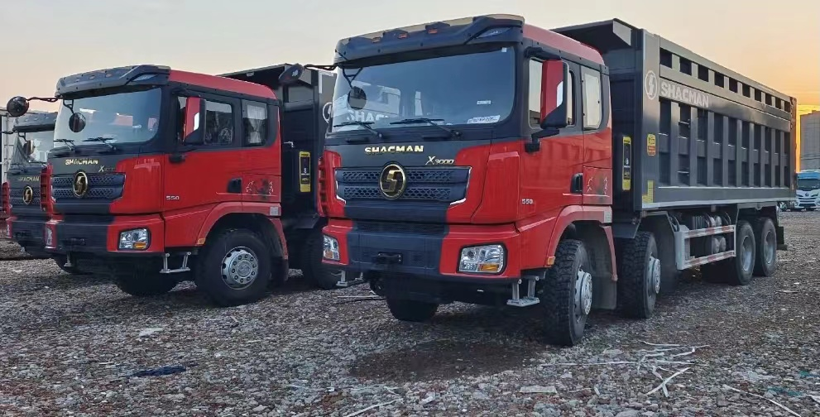

图片仅供参考

Pictures are for reference only

**Main Specifications主要参数**

|  |  |  |
| --- | --- | --- |
| MODEL/车型 | | SX33186V386 |
| Driver position/驾驶员位置 | | 左舵 Left Hand |
| Driving type/驱动形式 | | 8*4 |
| Wheelbase/轴距(mm) | | 1800+3775+1400 |
| Max. Speed/最高车速(km/h) | | 75km/h |
| Engine/发动机 | Brand/品牌 | WEICHAI/潍柴 |
| Model/型号 | WP12.430E50 |
| Emission Standard/排放 | EURO V |
| Rated output power/功率（PS） | 316KW/430HP |
| Displacement  (L)/排量 | 11.926L |
| Transmission/变速箱 | Brand/品牌 | FAST/法士特 |
| Model/型号 | 12JSDX220TA-B-铁壳-QH50 |
| Front axle/前轴 | Brand/品牌 | 汉德牌/HANDE |
| Model/型号 | MAN 9.5T |
| Rear axle/后桥 | Brand/品牌 | 汉德牌/HANDE |
| Model/型号 | 16T MAN双级桥 double reduction driving axle  Speed ratio 速比：5.262 |
| Clutch/离合器 | | ￠430 diaphragm clutch￠430离合器 |
| Steering/转向机 | | ZF technology/ ZF技术 |
| Frame/车架 | | 850x300(8+7) |
| Suspension/悬架 | | Front and rear multi-leaf spring four main flims+four horse riding bolts 前后多片簧  四主片+四骑马螺栓 |
| Fuel tank/燃油箱 | | 500L铝合金 Aluminum alloy |
| Wheels and tires/轮胎 | | 315-80R22.5国产无内胎 三角胎：TR918 20层级 |
| Brakes/制动 | | Running brake:Dual circuit compressed air brake/行车制动 |
| Parking brake:Air discharging with spring control/停车制动 |
| Auxiliary brake:Engine exhaust brake/发动机排气辅助制动 |
| Cabin/驾驶室 | | X3000中长平顶驾驶室不带顶导流罩、液压主座椅、四点液压悬置、普通后视镜、电控自动恒温空调（杰克塞尔压缩机）、电动摇窗机、手动翻转、金属保险杠、三级上车踏板、中控锁（带遥控器）、普通方向盘、油浴式空滤、大箱底板加热排气管、水箱保护栅、国产转向机、国产离合器、前后稳定杆、180Ah免维护电瓶、驾驶室后窗、门下护板、无侧工具箱、不预留全挂车电气路接口、铁储气筒、取消增加2个储气瓶、WABCO六通道ABS、无后防护、2公斤灭火器、驻车楔块、取消八字尾梁、普通拖钩、电加热油量传感器、无紧急呼叫格罗纳斯系统、不预留线束、集成式日间行车灯带E标、低温管线束、加装一级长效燃油粗滤器 |
| X3000 medium length flat top cab without top air deflector, hydraulic main seat, four point hydraulic suspension, ordinary rearview mirror, electrically controlled automatic constant temperature air conditioning (Jack's compressor), electric window rocking machine, manual flipping, metal bumper, three-level boarding pedal, central lock (with remote control), ordinary steering wheel, oil bath air filter, heated exhaust pipe for large box bottom plate, water tank protective grille, domestic steering gear, domestic clutch, front and rear stabilizer bar, 180Ah maintenance free battery, rear window of the cab, door guard plate, no side toolbox, no reserved electrical circuit interface for full trailer, iron air reservoir, no need to add 2 air cylinders, WABCO six channel ABS, no rear protection 2 kg fire extinguisher, parking wedge, cancellation of the eight shaped tail beam, ordinary towing hook, electric heating oil level sensor, no emergency call Gronas system, no reserved wiring harness, integrated daytime running lights with E-mark, low-temperature pipe wiring harness, installation of a first level long-lasting fuel coarse filter |
| Upbody/上装 | | 7600*2300*1500+500 (mm)Bottom 8 sides 6 |

|  |
| --- |
|  |
| Description/说明：   1. Terms of payment: T/T, 30% deposit, balance before delivery from factory.   支付条件：预付30%，工厂发车前付清尾款   1. Delivery at China port period: 55 working days after advance payment.   交货期：预付款后55个工作日到国内港口   1. Vehicle warranty period: 12 months from the date of bill of lading.   整车质保期：提单之日起12个月 |